1. **Prompt for amount, interest rate and no. of years and calculate simple interest.**

**function simpl()**

{

var p,r,t;

p=parseFloat(prompt("Please Enter Principle Amount"));

r=parseFloat(prompt("Please Enter Rate Amount"));

t=parseFloat(prompt("Please Enter Time(year)"));

var si=(p*r*t)/100;

document.write("Simple Interest (calculated anually) is: "+si);

}

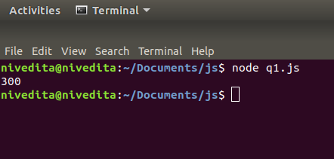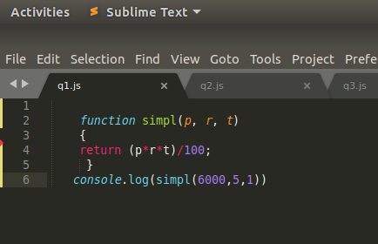

1. **is palindrome string**

var isPalindrome = function (string) {

if (string == string.split('').reverse().join('')) {

alert(string + ' is palindrome.');

}

else {

alert(string + ' is not palindrome.');

}

}

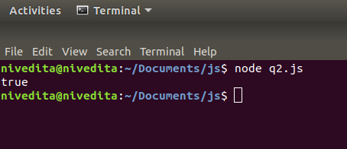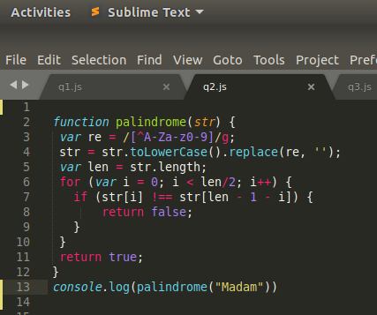

**3.Area of circle**

function CalculateArea(){

var radius =document.form1.txtRadius.value;

document.write("<P>The area of the circle is " + (radius * radius * Math.PI) + "</p>");

}

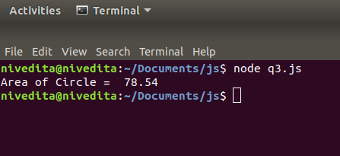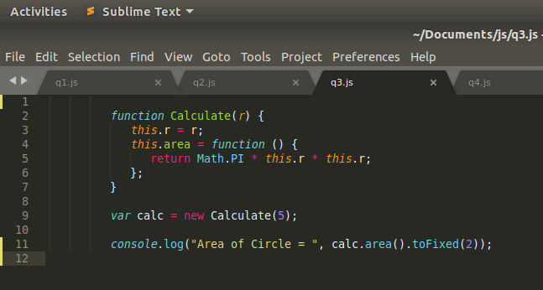

**4.Copy information of one object to another and log it to console.**

let obj = {

a: 1,

b: {

c: 2,

},

}

let newObj = JSON.parse(JSON.stringify(obj));

obj.b.c = 20;

console.log(obj);

console.log(newObj);

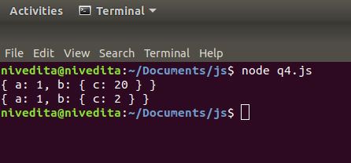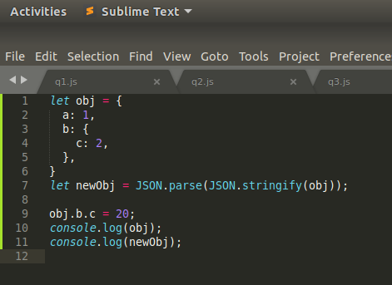

**5.create a list of objects of Employee with info as follow :**

* + **Name, age, salary ,DOB**
  + **filter all employees with salary greater than 5000**
  + **group employee on the basis of their age**
  + **fetch employees with salary less than 1000 and age greater than 20. Then give them an increment 5 times their salary.**

var db = [

{Name:'Demo', Age: 21, Salary: 50000, DOB:'01-01-2016'},

{Name:'Demo2', Age: 21, Salary: 70000, DOB:'01-01-2016'},

{Name:'Demo3', Age: 21, Salary: 80000, DOB:'01-01-2016'},

{Name:'Demo4', Age: 21, Salary: 90000, DOB:'01-01-2016'},]

**/* Question 5 Part 2*/**

console.log(db)

let incsal = [];

for (let i = 0; i< db.length; i++){

if (db[i].Salary > 5000){

incsal.push(db[i]);}}

console.log(incsal);

**/*Question 5 Part 3*/**

let groupt = db.reduce((r,a) => {

r[a.Age] = [...r[a.Age] || [], a]

return r;

},{});

**/* Question 5 Part 4*/**

let increment = [];

for (let k = 0; k< db.length; k++){

if (db[k].Salary < 1000 && db[k].Age>20){

let po = db[k].Salary * 5;

increment.push(po);}}

console.log(increment);